### Semester Two Examination, 2022

### Question/Answer booklet

# MATHEMATICS SPECIALIST

**UNITs 3 & 4**

## Section Two:

## Calculator-assumed

|  |
| --- |
|  |

Your Name

Your Teacher’s Name

## Time allowed for this section

Reading time before commencing work: ten minutes

Working time: one hundred minutes

## Materials required/recommended for this section

***To be provided by the supervisor***

This Question/Answer booklet

Formula sheet (retained from Section One)

***To be provided by the candidate***

Standard items: pens (blue/black preferred), pencils (including coloured), sharpener, correction fluid/tape, eraser, ruler, highlighters

Special items: drawing instruments, templates, notes on two unfolded sheets of A4 paper, and up to three calculators approved for use in this examination

## Important note to candidates

No other items may be taken into the examination room. It is **your** responsibility to ensure that you do not have any unauthorised material. If you have any unauthorised material with you, hand it to the supervisor **before** reading any further.

|  |  |  |  |  |  |
| --- | --- | --- | --- | --- | --- |
| **Question** | **Marks** | **Max** | **Question** | **Marks** | **Max** |
| **9** |  | **7** | **16** |  |  |
| **10** |  |  | **17** |  |  |
| **11** |  |  | **18** |  |  |
| **12** |  |  | **19** |  |  |
| **13** |  |  | **20** |  |  |
| **14** |  |  | **21** |  |  |
| **15** |  |  |

**Structure of this paper**

|  |  |  |  |  |  |
| --- | --- | --- | --- | --- | --- |
| Section | Number of questions available | Number of questions to be answered | Working time (minutes) | Marks available | Percentage of examination |
| Section One:  Calculator-free | 8 | 8 | 50 | 49 | 34 |
| Section Two:  Calculator-assumed | 11 | 11 | 100 | 97 | 66 |
|  |  |  |  | **Total** | 100 |

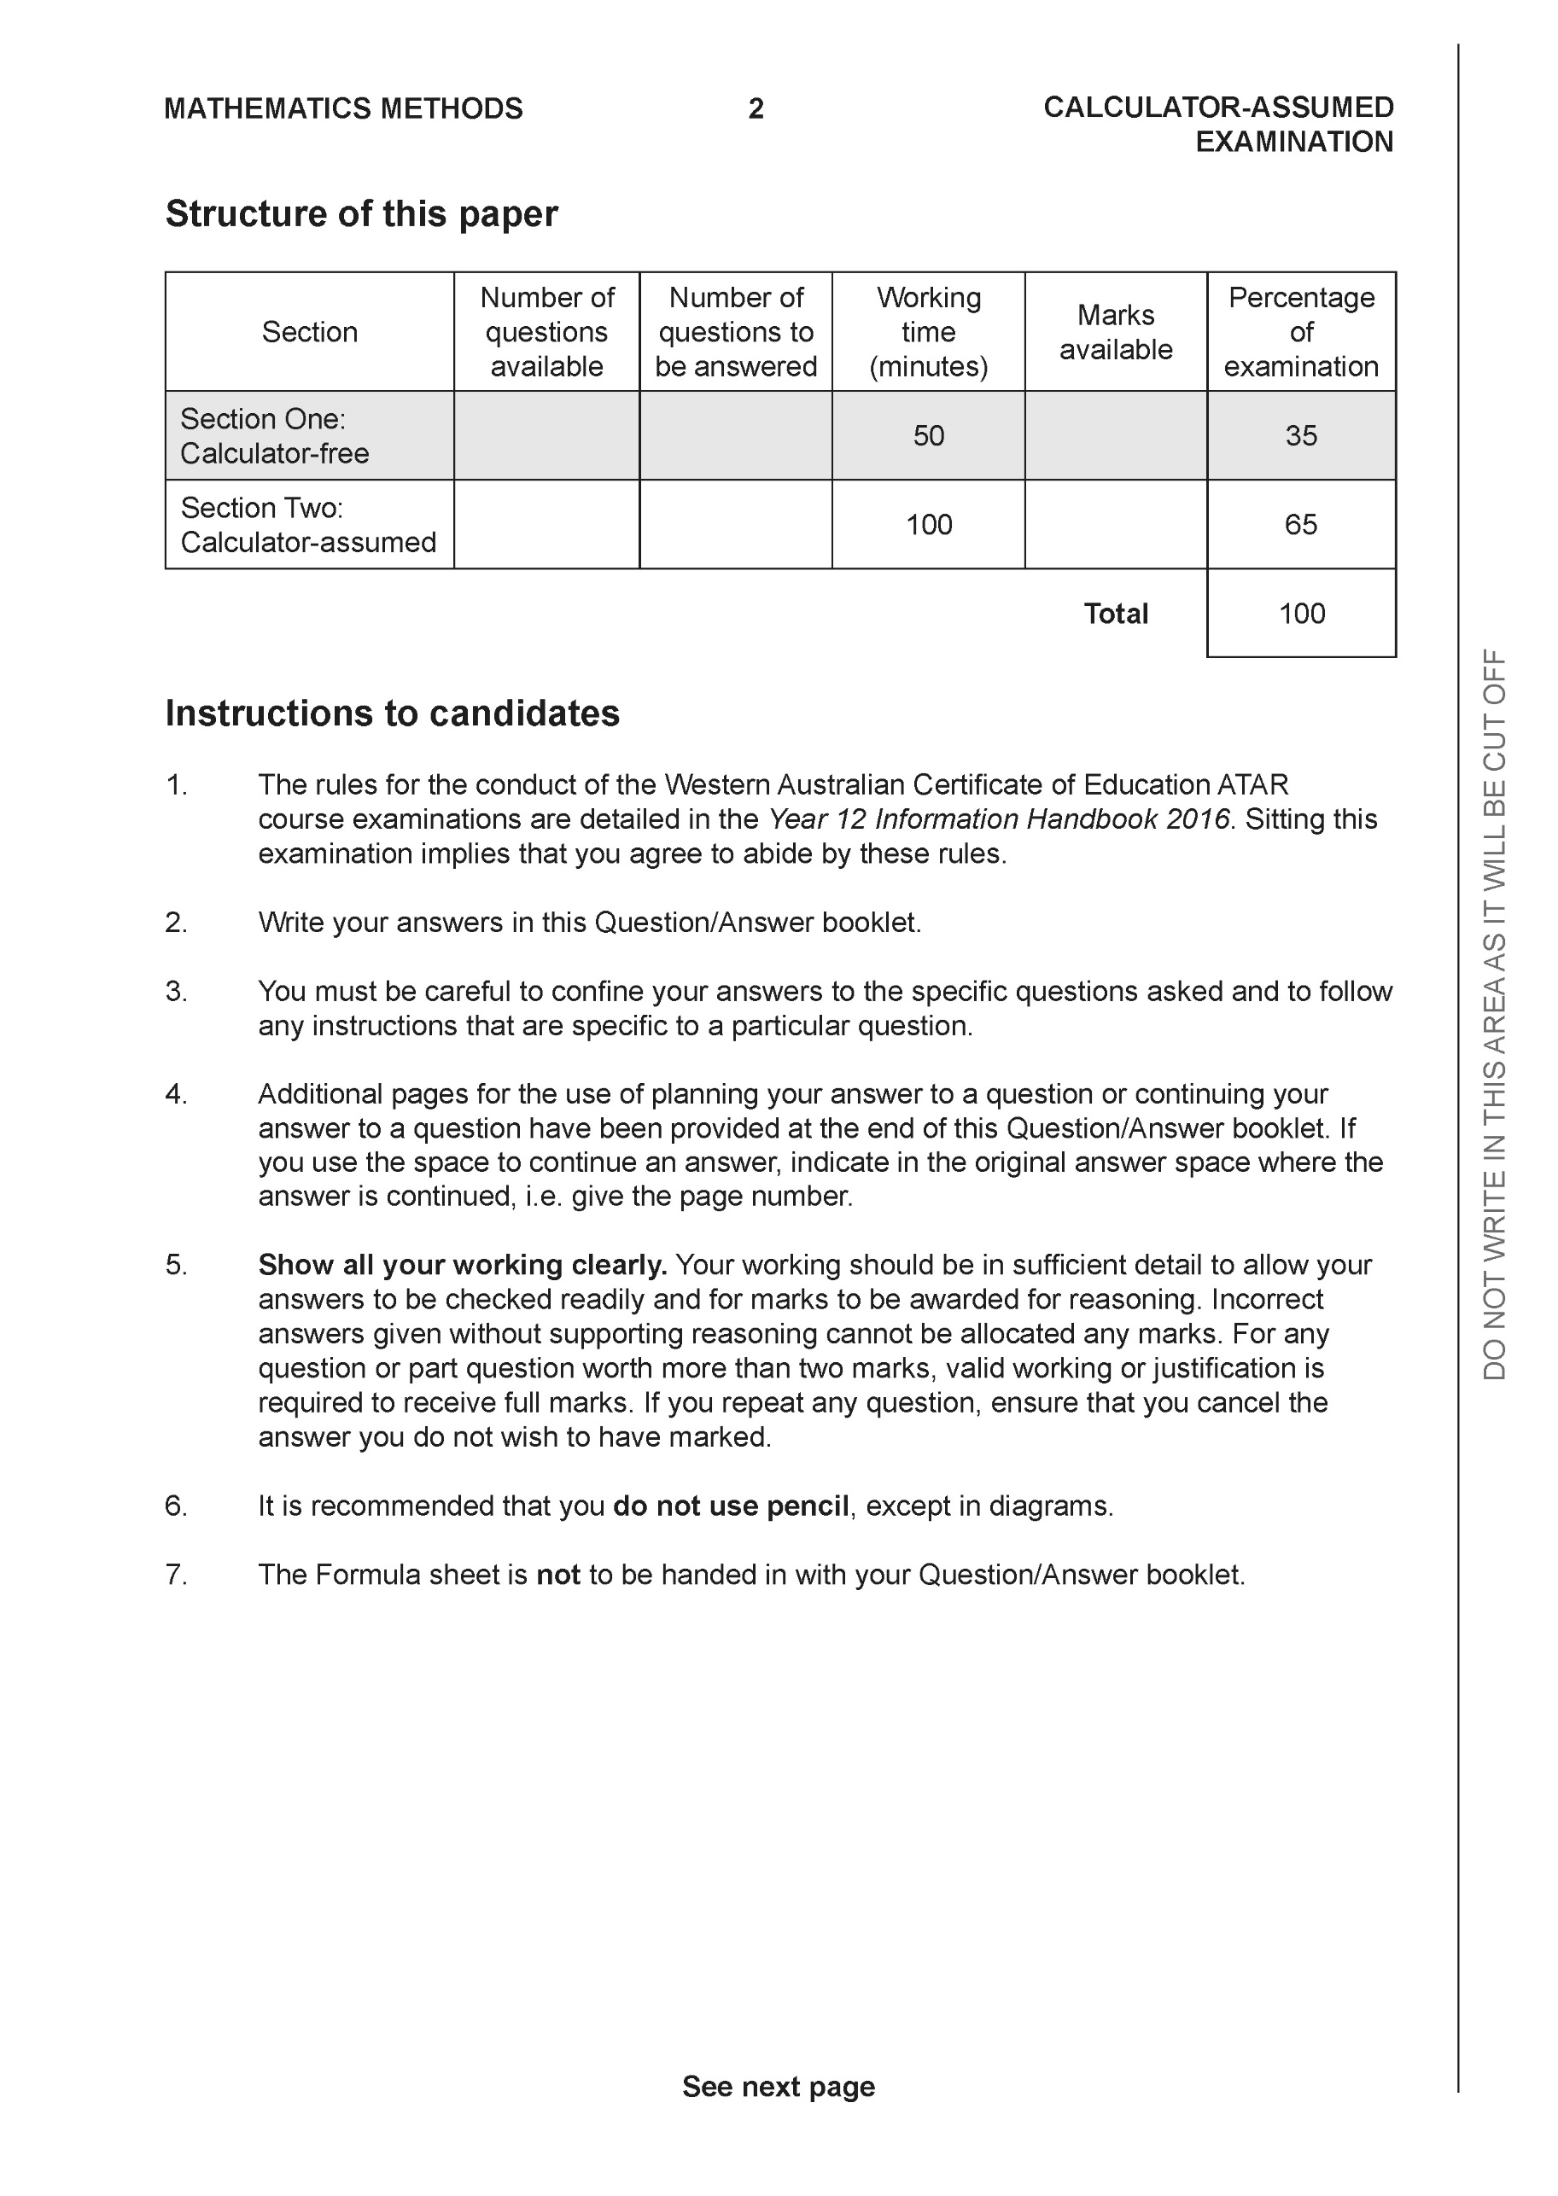

**Section Two: Calculator-assumed (97 Marks)**

This section has **11** questions. Answer **all** questions. Write your answers in the spaces provided.

Spare pages are included at the end of this booklet. They can be used for planning your responses and/or as additional space if required to continue an answer.

● Planning: If you use the spare pages for planning, indicate this clearly at the top of the page.

● Continuing an answer: If you need to use the space to continue an answer, indicate in the original answer space where the answer is continued, i.e. give the page number. Fill in the number of the question that you are continuing to answer at the top of the page.

Working time: 100 minutes.

**Question 9 (6 marks)**

Consider a ship moving towards the shore at 5m/s with a revolving light on the roof rotating

at10 rads/sec. This light causes a dot of light to move along the wall on the shore. Determine

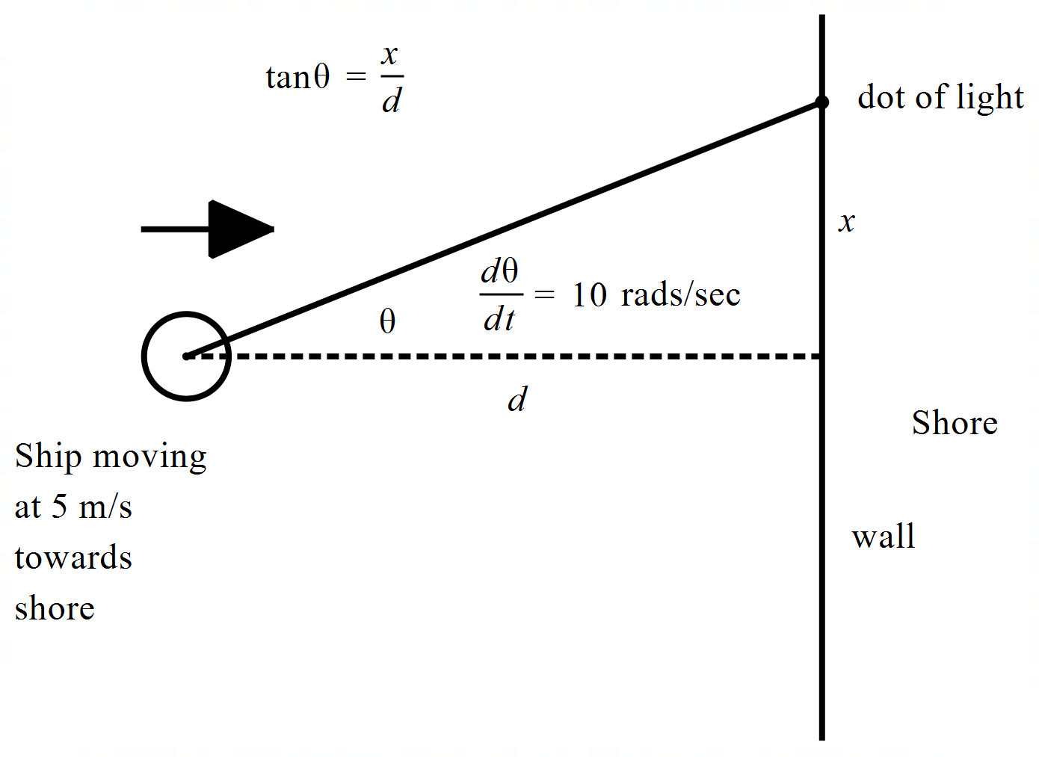the speed of the dot when the ship is 50 m from shore, m and the dot of light 3

metres from point directly opposite ship on shore, m. Answer to 2 decimal places in

m/s.

|  |
| --- |
| **Solution** |
|  |
| **Specific behaviours** |
| P uses product rule  P uses negative rate for distance of boat from shore  P uses value of secant  P uses rate of angle (+/- both accepted)  P obtains an expression for speed  Pstates speed to 2 dp ( |

**Question 10 (8 marks)**

1. On the axes below, sketch the slope field for  (3 marks)

|  |
| --- |
| **Solution** |
|  |
| **Specific behaviours** |
| P shows horizontal lines at x=-2&3  P shows negative lines on y axis  P shows steep positive lines at x=-10&10 |

1. On the axes above, sketch the solution curve that passes through the point (6,2)

(2 marks)

|  |
| --- |
| **Solution** |
|  |
| **Specific behaviours** |
| P cubic shape  P turning pts at x=-2&3 |

1. Determine the Cartesian equation of the curve for part (b) above. (3 marks)

|  |
| --- |
| **Solution** |
|  |
| **Specific behaviours** |
| P integrates  P adds a constant  P solves for constant using (6,2) |

**Question 11 (8 marks)**

Consider the point A , plotted on the Argand plane below.

1. Determine the polar form of point A,  (2 marks)

|  |
| --- |
| **Solution** |
|  |
| **Specific behaviours** |
| P modulus  P argument |

1. Plot the following value on the diagram above  (3 marks)

|  |
| --- |
| **Solution** |
|  |
| **Specific behaviours** |
| P converts factors to polar  P modulus unchanged  P rotated anti-clockwise 105 degrees |

1. Shade the following region on the axes above:

(3 marks)

|  |
| --- |
| **Solution** |
|  |
| **Specific behaviours** |
| P uses circle of radius 1.5  P lower limit of 30 degrees  P upper limit of 150 degrees |

**Question 12 (10 marks)**

An object is moving along a straight line such that  where , metres is the displacement from the origin. The maximum speed and the initial speed are both  m/s.

1. Determine an expression for at time  seconds. (2 marks)

|  |
| --- |
| **Solution** |
|  |
| **Specific behaviours** |
| P value of n  P Amplitude |

1. Determine the percentage of time in the long run that the object is no more than 2 metres from the origin. (4 marks)

|  |
| --- |
| **Solution** |
|  |
| **Specific behaviours** |
| P solves for when x=2  P uses period time  P sets up calculation for percentage  P states percentage |

1. Determine the speed and acceleration when the object is 1.5 metres from the origin.

|  |
| --- |
| **Solution** |
|  |
| **Specific behaviours** |
| P uses correct formula for speed and shows calculation  P states approx. speed  P uses correct formula for acceleration and shows calculation  P states acceleration |

(4 marks)

**Question 13 (5 marks)**

Consider a solid sphere of radius 9 metres with a cross-section as shown below.

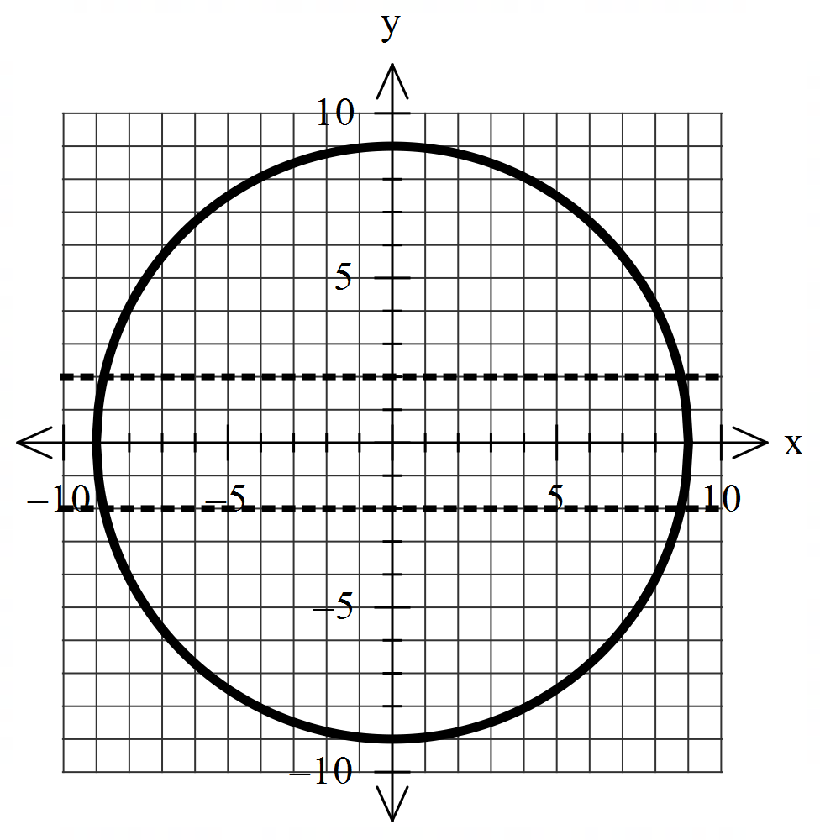

If a hollow cylinder of radius 2 metres, is drilled completely through the middle of the solid sphere, determine the volume of the sphere remaining.

|  |
| --- |
| **Solution** |
|  |
| **Specific behaviours** |
| P determines where y=2 intersects with circle  P uses a revolution around an axis  P sets up rule for integral  P uses appropriate limits on integral  Pstates volume (no need for units)  Full marks awarded if used the following method correctly |

**Question 14 (9 marks)**

1. Solve the following system of equations showing full working. (3 marks)



|  |
| --- |
| **Solution** |
|  |
| **Specific behaviours** |
| P eliminates one variable from two equations  P eliminates two variables from one equation  P solves for all 3 variables |

1. Determine all possible values of  such the below system has: (3 marks)



1. Unique solution
2. Infinite solutions
3. No solutions

|  |
| --- |
| **Solution** |
|  |
| **Specific behaviours** |
| P sets up equation with two coefficients in terms of p&q  P solves for unique values  P solves for infinite & no solutions |

1. For the values of  that give infinite solutions in (bii) above, determine the vector equation of the line of possible solutions. (3 marks)

|  |
| --- |
| **Solution** |
|  |
| **Specific behaviours** |
| P expresses two variables in terms of common parameter for p&q values infinite  P expresses all 3 variables in terms of common parameter  P sets up a vector equation for line |

**Question 15 (11 marks)**

It is found that for the entire population of Yr 12 students in Australia that the mean number for daily homework is 2.5 hours with a standard deviation of 1.6 hours. Samples of 80 students are taken and the students sampled are surveyed as to their daily homework hours.

1. Determine the probability that the mean number of homework hours in a sample is between 2 and 2.5 hours. (3 marks)

|  |
| --- |
| **Solution** |
|  |
| **Specific behaviours** |
| P states normal  P states mean stdev  P states prob |

Let  = sample mean of HW hours from samples of size 80 students.

1. Define the probability distribution of . (2 marks)

|  |
| --- |
| **Solution** |
|  |
| **Specific behaviours** |
| P states Normal with mean  P mean stdev |

1. Sketch the probability density function for on the axes below. (2 marks)

|  |
| --- |
| **Solution** |
|  |
| **Specific behaviours** |
| P Bell shape curve centred on T=2.5  P outer limits around 2 & 3 (3 stdevs) |

Q15 continued.

A sample of 100 Yr 12 students found that the mean number of HW hours is 2.0 hours with a sample standard deviation of 1.1 hours. It is suggested that this sample is from the United Kingdom.

1. Present an argument and necessary calculations to determine whether this suggestion is correct or not.

(4 marks)

|  |
| --- |
| **Solution** |
| 99% confidence interval    1.71664-2.28336  95% confidence interval  1.7844-2.2156  The Aust population mean does not lie in either interval which would support the idea that this sample is not from Aust but we cannot suggest UK or any other named country.  OR  The two above intervals may not contain the true population p as not all intervals do so. |
| **Specific behaviours** |
| P determines at least one confidence intervals (SCSA would prefer two)  P shows working for at least one confidence interval  P states that population mean does not fit in either interval  P states that does not supports Aust but cannot assume UK  OR no inference can be made as not all intervals contain true value of pop mean |

**Question 16 (11 marks)**

Consider the triangle  as with  and  as the origin.

1. Show that is an isosceles triangle. (3 marks)

|  |
| --- |
| **Solution** |
|  |
| **Specific behaviours** |
| P determines exact length of one side  P determines exact length of two sides  P states that both are equal hence isosceles |

1. Show that  lies in the plane . (3 marks)

|  |
| --- |
| **Solution** |
|  |
| **Specific behaviours** |
| P uses cross product to determine normal  P determines an equation for plane  P subs point to show is on plane |

1. Given that  show that the line  is perpendicular to the plane .

(2 marks)

|  |
| --- |
| **Solution** |
|  |
| **Specific behaviours** |
| P determines CD  P shows that is a scalar multiple of normal hence perpendicular to plane |

1. Given , determine the distance of pt  to the plane containing .

(3 marks)

|  |
| --- |
| **Solution** |
|  |
| **Specific behaviours** |
| P uses dot product with normal  P determines a vector between E and pt on plane Or uses line  P determines approx. distance |

**Question 17 (12 marks)**

In order to estimate the mean amount of superannuation for workers in Perth, , a sample of  workers were chosen with a sample mean of $90 000 and a sample standard deviation of  and a 90% confidence interval width of $30 000.

1. State the 90% confidence interval. (1 mark)

|  |
| --- |
| **Solution** |
|  |
| **Specific behaviours** |
| P states interval (no need for units) |

1. Determine the sample mean standard deviation. (2 marks)

|  |
| --- |
| **Solution** |
|  |
| **Specific behaviours** |
| P uses z quantile  P states stdev (no need to round) |

1. In terms of  , what sample size would give a 90% confidence interval of width of

$10 000? (3 marks)

|  |
| --- |
| **Solution** |
|  |
| **Specific behaviours** |
| P uses inverse ratio  P uses square of width ratio  P states new size in terms of n |

1. What is the probability to 3 dp that another sample size of 3 would give a sample mean that differs from  by no more than $15 000? (3 marks)

|  |
| --- |
| **Solution** |
|  |
| **Specific behaviours** |
| P determines new mean stdev  P uses z scores  P determines prob to at least 3 dp |

1. In each of the scenarios below, state whether the confidence interval width would increase or decrease. (3 marks)
2. Sample size trebled.
3. Confidence changed to 95%.
4. Sample standard deviation decreased.

|  |
| --- |
| **Solution** |
| 1. Decrease 2. Increase 3. decrease |
| **Specific behaviours** |
| P i  P ii  P iii |

**Question 18 (8 marks)**

An ellipse has equation .(Note:) The tangent at a point  with  , intersects the x and y axes at Points respectively. The origin is at .

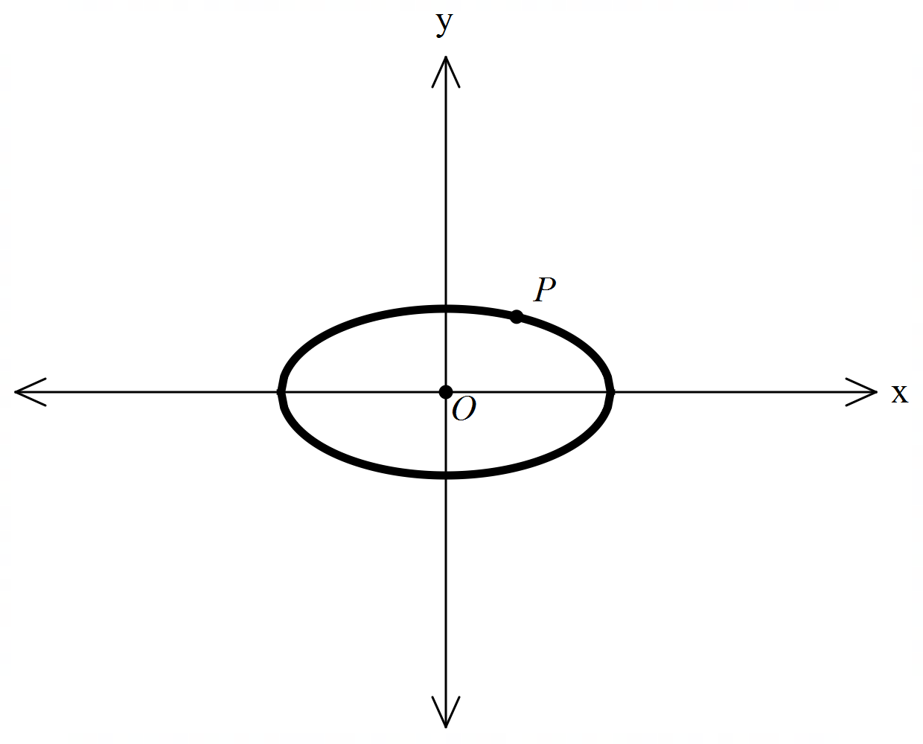

1. Determine the area of triangle  in terms of . (4 marks)

Note: Diagram is not drawn to scale.

|  |
| --- |
| **Solution** |
|  |
| **Specific behaviours** |
| P uses implicit diff to find gradient OR indicates use of tangent line  P expresses gradient in terms of angle,a&b  P determines constant of tangent  P obtains expression for area using intercepts |

1. Determine the values of  for which the area of triangle  is a minimum and state this minimum area in terms of . (4 marks)

|  |
| --- |
| **Solution** |
| , as |
| **Specific behaviours** |
| P differentiates in terms of angle  P equates to zero  P gives one possible value for angle  P gives positive area |

**Question 19 (9 marks)**

Consider a train that suddenly brakes causing a deceleration of  metres per second squared, where  equals its velocity. (Note:)

1. Show that  , where  is the distance travelled from when the brakes are first applied. (3 marks)

|  |
| --- |
| **Solution** |
|  |
| **Specific behaviours** |
| P uses for acceleration  P uses negative sign for acceleration  P obtains final expression with reasoning |

1. If  is the velocity of the train when the brakes are first applied, show that the train comes to rest when . (3 marks)

|  |
| --- |
| **Solution** |
|  |
| **Specific behaviours** |
| P separates dv and dx and writes integral  P solves for constant  P solves for x when v=0 and simplifies |

1. Show that the train stops when  (3 marks)

(Hint- use the substitution  )

|  |
| --- |
| **Solution** |
|  |
| **Specific behaviours** |
| P changes variable to angle OR determines  P simplifies integral  P solves for t when v=0 |